|  |  |  |
| --- | --- | --- |
| 1165635709  **DEPARTMENT OF COMPUTER SCIENCE**  **APPROVAL FOR BINDING OF GRADUATION PROJECT REPORT** | | |
| **GRADUATION PROJECT (ITEC 425)**  **GROUP: GROUP NUMBER** | | |
| **SESSION 2023 / 2024** | | |
|  |  |  |
| ***To be filled in by student*** | | |
| Student name(s) | : | |  |  | | --- | --- | |  |  | |
| University ID(s). | : | |  |  | | --- | --- | |  |  | |
| Project title | : | **PROJECT NAME** |
|  |  |  |
| ***To be filled in by supervisor*** | | |
| **This is to certify that the project submitted and presented by the above mentioned student(s) is**  **🞏 COMPLETE & ACCEPTED 🞏 INCOMPLETE 🞏NOT ACCEPTED**  **and the draft of graduation project report has been corrected from all content flaws, typing errors and language mistakes.** | | |
| Supervisor name | : | **SUPERVISOR NAME** |
| Signature | : | **SUPERVISOR SIGNATURE** |
| Date | : | **SIGN DATE** |
|  | | |
| ***For Departmental Office use only*** | | |
| Date received | : |  |
|  |  |  |
| Signatures | : |  |

Acknowledgement

We would like to extend our heartfelt appreciation to everyone who played a role in this journey. First and foremost, we are deeply grateful to Allah for granting us the strength and guidance to bring this task to fruition. Our sincere thanks go to Dr. , our mentor, whose insights and guidance have been instrumental in deepening our understanding of this project. His invaluable suggestions and directions were pivotal in the successful completion of this endeavor. Lastly, our profound gratitude goes to our parents and friends, whose unwavering support and invaluable counsel have been a constant source of strength throughout the duration of this project.

Abstract

In our modern era, with the advancement of science and artificial intelligence, medical equipment must be developed, just like entertainment, sports, movies, and other matters of life. It is necessary to facilitate access to doctors and nurses and medicines without going to distant centers or pharmacies, and artificial intelligence has helped us to do this and made the matter as simple as it can be. Access to medicines and prescriptions faster. The user can search and read about the medicine, inquire about its benefits and harms, and communicate with technical support if there is a problem. This electronic pharmacy is designed to be useful for the patient or others to search for what they need.

Table of content

Chapter 1 | INTRODUCTION

1.1 Introduction …………………………………………………………………………7

1.2 Problem Background. ……………………………………………………………….8

1.3 Problem Definition / Problem Statement …………………………………10

1.4 Project Goals and Objectives…………………………………………………….12

1.5 Project Motivation, Potential Benefits……………………………………..13

1.6 Project Scope…………………………………………………………………………..15

1.7 Work Breakdown Structure & Gantt Chart………………………………16

Chapter 2 | SYSTEM ANALYSIS

2.1 Development Methodology ……………………………………………………19

2.2 User and System Requirements………………………………………………21

2.2.1 Functional Requirements……………………………………………………..21

2.2.2 Non-Functional Requirements……………………………………………..23

2.2.3 Hardware Requirements Specifications………………………………..24

2.2.4 Software Requirements Specifications………………………………….24

2.3 System Analysis Models……………………………………………………………25

2.3.1 Use Case Diagram………………………………………………………………….25

Chapter 3 | SYSTEM DESIGN

3.1 System Architecture………………………………………………………………..28

3.2 Class Diagram…………………………………………………………………………..30

3.3 Database Design (ER diagram)……………………………………………. …..31

Chapter 4 | CONCLUSION

4.1 Conclusion………………………………………………………………………………34

**Chapter 1 | INTRODUCTION**

**1.1 INTRODUCTION:**

In recent years, the rapid advancement of technology has revolutionized various sectors, and the healthcare industry is no exception. One remarkable development in this field is the emergence of E-Pharmacy, an innovative model that utilizes digital platforms to facilitate the purchase and delivery of medicines. E-Pharmacy has the potential to transform the way people access healthcare, providing numerous benefits such as convenience, accessibility, and improved medication management.

The objective of this project is to delve into the world of E-Pharmacy, exploring its underlying concepts, advantages, challenges, and potential impact on the healthcare ecosystem. By examining the current landscape, regulatory frameworks, and consumer perceptions, we aim to gain a comprehensive understanding of this transformative digital solution.

**1.2 Problem Background:**

The healthcare industry has traditionally relied on brick-and-mortar pharmacies as the primary means of dispensing medications to patients. However, this traditional model presents several challenges and limitations, which have led to the emergence of the E-Pharmacy model.

1. Accessibility: Physical pharmacies are often concentrated in urban areas, leaving individuals in rural or remote locations with limited access to necessary medications. This lack of accessibility can result in delayed or inadequate treatment, particularly for individuals with chronic illnesses or limited mobility.

2. Convenience: Traditional pharmacies operate within specific hours, making it difficult for individuals with busy schedules or those requiring urgent medication to obtain their prescriptions in a timely manner. E-Pharmacy addresses this issue by offering round-the-clock access to a wide range of medications and healthcare products.

3. Medication Errors: Human error in prescription filling and dispensing can lead to medication errors, including incorrect dosages, wrong medications, or drug interactions. E-Pharmacy systems incorporate digital technologies that help automate the prescription process, reducing the likelihood of such errors and enhancing patient safety.

4. Counterfeit Medicines: The prevalence of counterfeit medicines is a significant concern in many regions. Traditional supply chains can be vulnerable to counterfeit products, compromising patient safety. E-Pharmacy platforms can implement rigorous quality control measures and traceability systems to ensure the authenticity and integrity of medications.

5. Medication Adherence: Non-adherence to prescribed medications is a common problem, leading to treatment failures and adverse health outcomes. E-Pharmacy platforms can leverage technology to provide medication reminders, dosage instructions, and personalized health information, promoting better adherence and patient outcomes.

6. Patient Empowerment: E-Pharmacy empowers patients by providing them with access to comprehensive medication information, including potential side effects, contraindications, and drug interactions. This enables patients to make informed decisions about their healthcare and actively participate in managing their conditions.

7. Regulatory Challenges: The rapid growth of E-Pharmacy has raised regulatory challenges related to patient safety, data privacy, prescription validity, and adherence to pharmaceutical regulations. Developing appropriate legal frameworks and regulatory standards that ensure patient safety and quality of care while fostering innovation is a complex task.

8. Consumer Perception and Trust: The concept of purchasing medications online is relatively new, and some individuals may have concerns regarding the authenticity, reliability, and security of E-Pharmacy platforms. Building consumer trust and confidence in these digital healthcare solutions is crucial for their widespread adoption.

**1.3 Problem Definition:**

The project on E-Pharmacy aims to address several key problems and challenges associated with the traditional model of medication dispensing and explore the potential of digital solutions. The primary problem areas that this project seeks to address include:

1. Limited Accessibility: Many individuals, particularly those in rural or remote areas, face challenges in accessing necessary medications due to a lack of nearby pharmacies. The traditional model of brick-and-mortar pharmacies hinders accessibility for these populations, leading to delayed or inadequate treatment.

2. Inconvenience and Time Constraints: Traditional pharmacies typically operate within specific hours, making it difficult for individuals with busy schedules or those requiring urgent medications to obtain their prescriptions promptly. This inconvenience can significantly impact patient adherence and overall healthcare outcomes.

3. Medication Errors: Human errors in prescription filling and dispensing can occur in traditional pharmacies, leading to medication errors such as incorrect dosages or dispensing the wrong medication. These errors can have serious consequences for patient safety and well-being.

4. Counterfeit Medicines: The prevalence of counterfeit medicines is a significant concern in many regions, posing serious risks to patients. Traditional supply chains may be susceptible to counterfeit products, compromising patient safety and undermining trust in the healthcare system.

5. Medication Adherence: Non-adherence to prescribed medications is a widespread problem, resulting in treatment failures and suboptimal health outcomes. Traditional pharmacies often lack the tools and resources to effectively support medication adherence among patients.

6. Regulatory Challenges: The rapid growth of E-Pharmacy has raised regulatory challenges related to patient safety, data privacy, prescription validity, and adherence to pharmaceutical regulations. Developing appropriate legal frameworks and regulatory standards that ensure patient safety while fostering innovation is crucial.

7. Consumer Perception and Trust: The concept of purchasing medications online is relatively new, and some individuals may have concerns regarding the authenticity, reliability, and security of E-Pharmacy platforms. Building consumer trust and confidence in these digital healthcare solutions is essential for their widespread adoption.

**1.4 Project Goals and Objectives:**

The e-pharmacy aims to facilitate the customer’s access to what he needs from the pharmacy, facilitate the search for what he needs, and improve the quality of the pharmacy. Here are the most important goals as follows:

Improving the efficiency of pharmaceutical operations: Streamlining drug distribution and inventory management processes to improve efficiency.

Enhancing patient care: Providing tools to improve patient care and coordinate medication administration.

Increasing access to pharmaceutical services: Expanding access to patients through electronic services.

Compliance with legislation and standards: Ensure compliance with the requirements of industry laws and standards in the field of pharmacy.

Improving communication and reducing errors: Facilitating communication and reducing medication errors through an integrated electronic pharmacy system.

Improve inventory management: Improve inventory management to effectively supply medicines and avoid waste.

Data analysis for continuous improvement: Using data analytics to understand medication use and continuously improve pharmacy services.

These goals help direct efforts towards achieving the desired results effectively and specifically.

**1.5 Motivation and Potential Benefits:**

The motivation behind the project on E-Pharmacy stems from the potential benefits it offers to individuals, healthcare providers, and the healthcare system as a whole. By exploring and understanding these benefits, we can effectively advocate for the adoption and implementation of E-Pharmacy solutions. Some of the key potential benefits include:

1. Improved Accessibility: E-Pharmacy breaks down geographical barriers, providing access to medications for individuals in remote areas or those with limited mobility. It ensures that individuals can conveniently obtain their prescribed medications regardless of their location, enhancing healthcare equity and reducing health disparities.

2. Convenience and Time Efficiency: E-Pharmacy platforms offer 24/7 accessibility, allowing individuals to order medications at their convenience. This eliminates the need to visit physical pharmacies during specific operating hours, saving time and effort. Additionally, home delivery services provided by E-Pharmacy platforms further enhance convenience, particularly for individuals with chronic illnesses or disabilities.

3. Enhanced Medication Safety: E-Pharmacy systems employ digital technologies to automate the medication dispensing process, reducing the risk of human errors in prescription filling and dispensing. Electronic systems can flag potential drug interactions, allergies, or contraindications, improving patient safety and reducing adverse drug events.

4. Expanded Medication Information: E-Pharmacy platforms provide comprehensive medication information, including dosage instructions, potential side effects, and drug interactions. This empowers patients to make informed decisions about their medications and enhances their understanding of their treatment plans, promoting medication adherence and better health outcomes.

5. Cost Savings: E-Pharmacy platforms often offer competitive pricing, discounts, and bulk purchase options, leading to potential cost savings for both patients and healthcare systems. Additionally, by reducing the need for physical infrastructure and streamlining supply chains, E-Pharmacy models have the potential to lower healthcare costs in the long run.

6. Medication Adherence Support: E-Pharmacy platforms can incorporate features such as medication reminders, refill alerts, and personalized health information. These tools help individuals stay on track with their medication schedules, enhancing medication adherence and improving treatment outcomes.

7. Reduction of Counterfeit Medicines: E-Pharmacy systems can implement robust quality control measures and traceability systems to ensure the authenticity of medications. By reducing the circulation of counterfeit drugs, E-Pharmacy contributes to patient safety and public health.

8. Integration with Telemedicine: E-Pharmacy can be seamlessly integrated with telemedicine services, allowing patients to consult with healthcare professionals online and receive prescriptions electronically. This integration enhances the continuity of care, particularly for individuals in remote areas or those with limited access to healthcare facilities.

9. Data-driven Healthcare: E-Pharmacy platforms generate a wealth of data regarding medication usage, patient behavior, and healthcare trends. Aggregated and anonymized data can be leveraged to gain insights into population health, optimize treatment protocols, and improve health outcomes on a broader scale.

10. Innovation and Advancement: E-Pharmacy represents a significant shift in the healthcare landscape, leveraging technology and digital solutions to improve access to medications. By embracing E-Pharmacy, healthcare systems can drive innovation, foster collaboration between healthcare and technology sectors, and pave the way for future advancements in healthcare delivery

**1.6 The scope:**

The scope of e-pharmacy is to provide medicines and other health products to customers online. A licensed online pharmacy works like any other pharmacy, with pharmacists verifying prescriptions and dispensing the appropriate medications. Online pharmacies can provide customers with a wide range of benefits, including:

Convenience: Customers can order medicines and have them delivered to their homes or workplaces. This saves time spent traveling to the pharmacy and waiting for the medication to be dispensed.

Wide Choice: Online pharmacies can carry a wider range of medicines and health products than traditional pharmacies. This enables customers to find the medications they need even if they are not available in local pharmacies.

Competitive prices: Online pharmacies may offer lower prices for medicines and health products compared to traditional pharmacies. This is due to the lower overhead expenses associated with running an online pharmacy.

Privacy: Customers can order medicines and health products privately online. This is important for people with sensitive health conditions.

However, there are also some things to consider when using an online pharmacy:

Make sure that the online pharmacy is licensed by a government regulatory body.

Ensure that your online pharmacy uses strict security measures to protect your personal information.

Read about the online pharmacy's history to make sure it has a good reputation.

**1.7 Work Breakdown Structure & Gantt Chart:**

A Work Breakdown Structure (WBS) is a project management tool that breaks down a project into smaller, more manageable components or tasks. It's a hierarchical decomposition of the total scope of work to be carried out by the project team to accomplish the project objectives and create the required deliverables. The main goals of a WBS are to:

Organize and Define the Total Scope of the Project: It encompasses all work that must be done.

Facilitate Better Planning: By breaking down tasks, it becomes easier to estimate resources, costs, and timelines.

Assign Responsibilities: It helps in defining roles and responsibilities for each part of the project.

Track Progress: Facilitates monitoring and controlling of the project development.

Improve Communication: Provides a common understanding of the project scope among all stakeholders.

Each level of the WBS is a finer level of detail. The top level represents the project as a whole, with subsequent levels representing major deliverables or phases. The lowest levels of a WBS include work packages that can be scheduled, cost-estimated, monitored, and controlled.

In the context of the "Electronic pharmacy project" project, the WBS would break down this large and complex project into smaller, more manageable parts. Let's discuss each component:

Requirements Specification: This initial phase involves defining what the platform needs to do. It includes hardware and software specifications to ensure that the platform has the necessary infrastructure and software environment.

System Analysis: This phase focuses on understanding the functional (e.g., what the system should do) and non-functional requirements (e.g., performance, usability, reliability) of the platform.

System Design: Here, the project team designs the system architecture, database, and user interface. This phase turns the requirements into a blueprint for constructing the platform.

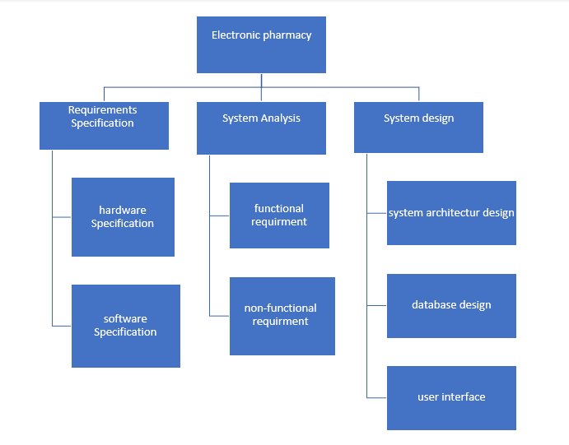

**Gantt Chart:**

The Gantt Chart serves as a visual timeline for the project, outlining the start and end dates of each task identified in the WBS, additionally it provides a clear schedule of activities, highlighting dependencies and parallel processes. This ensures that the project team can prioritize tasks effectively and adhere to the timeline. The Gantt Chart also facilitates regular monitoring and updating of the project status, allowing for adjustments in response to any unforeseen challenges or changes in scope.

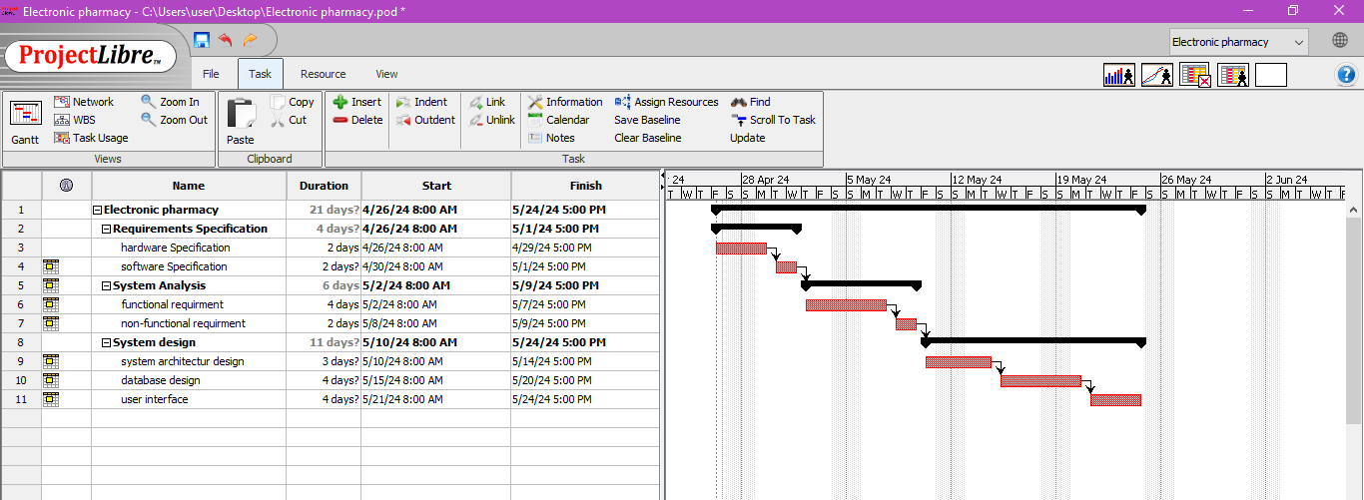

**Chapter 2 | SYSTEM ANALYSIS**

**2.1 Development Methodology:**

To develop the “Electronic Pharmacy” we will use what is called waterfall, a development approach that will explain how this project was developed , and we will mention it successively:

1. Requirements Gathering: In this initial phase, the requirements for the electronic pharmacy system are gathered from stakeholders, including pharmacists, administrators, and regulatory bodies. The requirements are documented in detail, including functionality, user interface specifications, and integration requirements.

2. System Design: Based on the gathered requirements, the system architecture and design are created. This includes defining the database schema, data flow diagrams, and screen layouts. The design documentation should be comprehensive and provide a blueprint for the development process.

3. Implementation: The implementation phase involves coding the software according to the design specifications. Developers write the code, following the design documentation. This phase also includes setting up the necessary infrastructure, such as servers and databases, and integrating any third-party components or APIs.

4. Testing: Once the implementation is complete, the system undergoes testing. This includes various types of testing, such as unit testing, integration testing, and system testing. Test cases are created based on the requirements, and the system is validated to ensure that it functions correctly and meets the specified criteria.

5. Deployment: After successful testing, the system is deployed to the production environment. This involves installing the software on the servers, configuring the system, and migrating any necessary data. The deployment process should be carefully planned and executed to minimize disruption to existing operations.

6. Maintenance: Once the system is live, ongoing maintenance and support are required. This includes monitoring the system for any issues, such as performance bottlenecks or security vulnerabilities, and addressing them promptly. Regular updates and bug fixes may be released as necessary.

By using the waterfall approach, everyone working on the project can not only understand its complexity, but also enable them to develop, maintain, and perform tests more easily.

**2.2 User and System Requirements**

2.2.1 Functional Requirements

Functional requirements of an electronic pharmacy system may include:

1. User Registration and Authentication: The system should allow users, such as patients, doctors, and pharmacists, to register and authenticate themselves securely.

2. Medication Ordering: Users should be able to browse and search for medications, view their details, and place orders electronically. The system should support prescription-based ordering, where users can upload or submit electronic prescriptions.

3. Prescription Management: The system should enable doctors to generate electronic prescriptions securely, including details such as medication name, dosage, frequency, and duration. It should also allow pharmacists to validate and process prescriptions.

4. Inventory Management: The system needs to maintain an up-to-date inventory of available medications, including information on stock levels, expiration dates, and batch numbers. It should provide alerts and notifications when stock levels are low or when medications are about to expire.

5. Online Payment and Billing: Users should be able to make online payments for their medication orders securely. The system should support various payment methods and integrate with payment gateways. It should also generate invoices and provide billing information.

6. Medication Dispensing: Pharmacists should be able to process medication orders, verify prescriptions, dispense medications accurately, and provide proper labeling and packaging.

7. Patient Records and History: The system should maintain electronic records of patients, including their personal information, medical history, allergies, and medication history. It should allow authorized healthcare professionals to access and update these records securely.

8. Drug Interaction Checking: The system should have a built-in mechanism to check for potential drug interactions and provide alerts to healthcare professionals and patients when there is a risk of adverse effects.

9. Communication and Notifications: The system should facilitate secure communication between users, such as doctors, pharmacists, and patients. It should provide notifications for order status updates, prescription changes, medication reminders, and other relevant information.

10. Reporting and Analytics: The system should offer reporting capabilities to generate various reports, such as medication usage statistics, sales reports, inventory reports, and patient demographics. These reports can help in monitoring and improving the pharmacy's operations.

11. Compliance and Security: The system should comply with relevant laws and regulations related to privacy, data security, and healthcare standards. It should ensure data confidentiality, integrity, and availability.

12. Integration with External Systems: The electronic pharmacy system may need to integrate with other healthcare systems, such as electronic health records (EHRs), insurance systems, and healthcare provider networks, to exchange information seamlessly.

It's important to note that the specific functional requirements may vary depending on the scope and scale of the electronic pharmacy system being developed.

2.2.2 Non-functional requirements:

Non-functional requirements of an electronic pharmacy system may include:

1. Performance Requirements: Ensure fast response times and the ability to support many users simultaneously.

2. Security Requirements: Protect data during transmission, regularly assess system vulnerabilities, and comply with data protection laws.

3. Reliability and Availability: Aim for high system uptime and implement measures to safeguard data integrity and availability.

4. Usability: Design a user interface that is easy to use for people with various levels of technical skills, including support for multiple languages and accessibility features.

5. Maintainability and Scalability: Facilitate easy system maintenance and updates, and ensure the system can grow to accommodate more users and data.

6. Compliance and Standards: Adhere to web standards and legal requirements related to media content and user privacy.

7. Environmental: Optimize the system for energy efficiency to reduce environmental impact.

8. Portability: Ensure compatibility with various browsers and mobile platforms, and ease of integration with other systems.

**2.2.3 Hardware Requirements Specifications**

We will mention The hardware requirement specification everything that was used for this project:

|  |  |  |
| --- | --- | --- |
| Item | | Description |
| 1 | **System** | **Windows 9 or higher** |
| 2 | **Processor** | **Corei5 or higher** |
| 3 | **Hard Disk** | **500 GB or higher** |
| 4 | **Ram** | **8GB or higher** |

**2.2.4 Software Requirements Specifications**

Software Requirements Specifications that were used in the “Electronic Pharmacy project”

|  |  |
| --- | --- |
| Technology / Tool | Usage |
| HTML and CSS | Design and Styling the system front – end pages |
| MYSQL Server | System back – end database |
| Google Chrom | Testing and viewing the web application |
| Vercel | Used for hosting |
| MongoDb | Database and storing |
| ReactJs | Framework for designing |
| NextJs | Combining database with the design of front end |

**2.3 System Analysis Models**

**2.3.1 Use Case Diagram**

Administrator Use Case Diagram: This diagram shows what are the access permissions of the admin in the electronic pharmacy

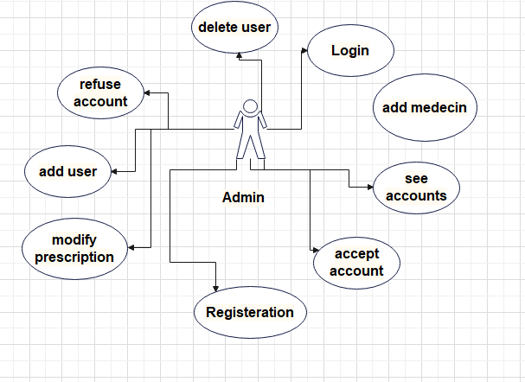

Pharmacist Use Case Diagram: This diagram shows what pharmacist access permissions are in the electronic pharmacy

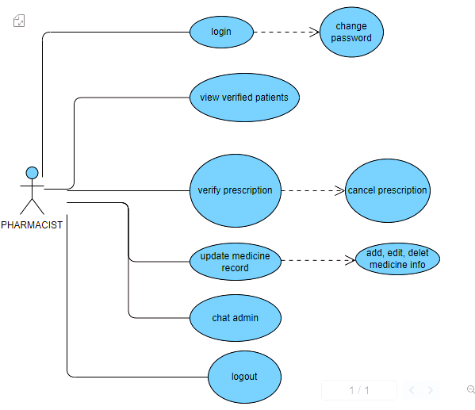

Customer Use Case Diagram:This diagram shows what the customer’s access permissions are in the electronic pharmacy

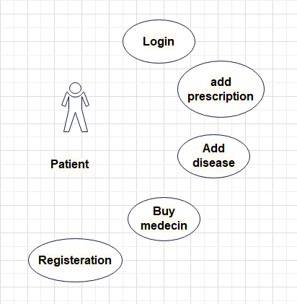

**Chapter 3 | SYSTEM DESIGN**

**3.1 System Architecture**

The system architecture diagram represents the structural design of an e-pharmacy, and it features three basic user roles: system administrator, pharmacist, and customer, each of whom interacts with a front-end site. The front-end site acts as an interface layer that facilitates user interactions and content display. This interface communicates with the back-end web server, which coordinates the platform's logic, data processing, and handles HTTP requests. The backend connects to a PostgreSQL database, where all data related to media content, user profiles and system interactions are stored and managed. This architecture ensures a clear separation of concerns, where the backend deals with data management and business logic, while the frontend focuses on user experience and presentation. The design allows for scalability and maintainability, accommodating the evolving needs of different user types and platform growth.

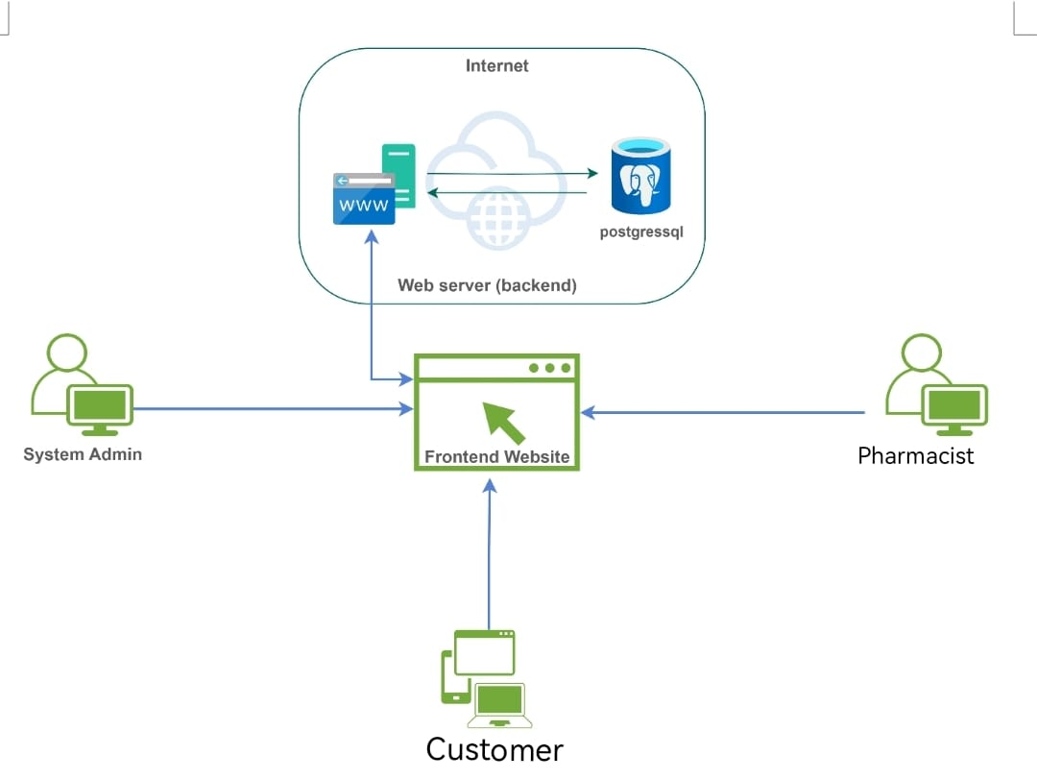

**3.2 Class Diagram**

A class diagram is a type of static structure diagram that represents the structure of a system by showing the system's classes, their attributes, operations (or methods), and the relationships among the classes. It's a foundational tool used in object-oriented modeling and provides a visual representation of the concepts and blueprints for the system's code structure.

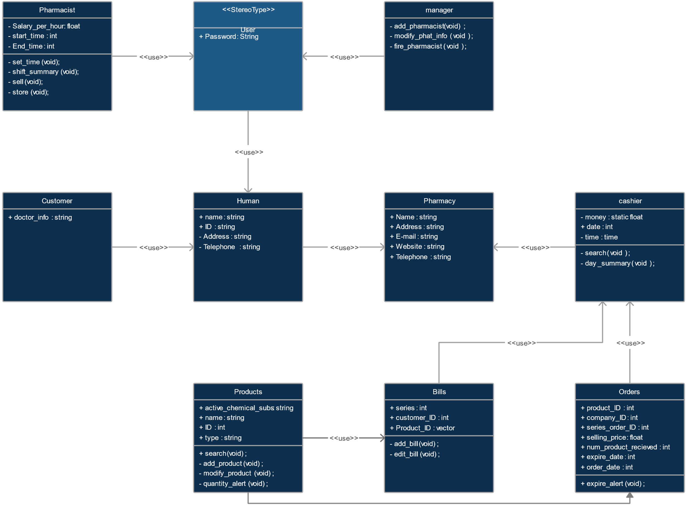

**3.3 Database Design (ER diagram)**

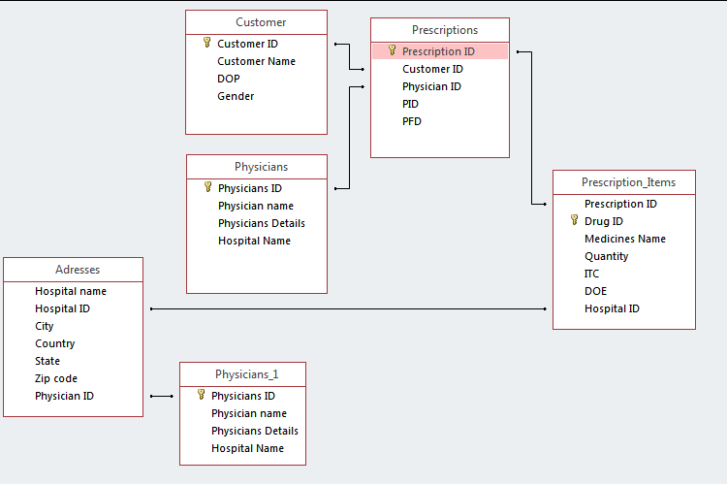

**Customer Table**

|  |  |
| --- | --- |
| Column Name | Data Type |
| CustomerID | **VARCHAR(255)** |
| Customer name | **TEXT** |
| DOP | **VARCHAR(255)** |
| Gender | **TEXT** |

**Prescription Table**

|  |  |
| --- | --- |
| Column Name | Data Type |
| PrescriptionID | **VARCHAR(255)** |
| CustomerID | **VARCHAR(255)** |
| PhysicianID | **VARCHAR(255)** |
| PID | **VARCHAR(255)** |
| PFD | **TEXT** |

**Physicians Table**

|  |  |
| --- | --- |
| Column Name | Data Type |
| PhysiciansID | **VARCHAR(255)** |
| Physicians name | **TEXT** |
| Physicians details | **TEXT** |
| Hospital Name | **TEXT** |

**Prescription_Items Table**

|  |  |
| --- | --- |
| Column Name | Data Type |
| PrescriptionID | **VARCHAR(255)** |
| DrugID | **VARCHAR(255)** |
| Medicines name | **TEXT** |
| Quantity | **VARCHAR(255)** |
| ITC | **TEXT** |
| DOE | **TEXT** |
| Hospital ID | **VARCHAR(255)** |

**Addresses Table**

|  |  |
| --- | --- |
| Column Name | Data Type |
| HospitalID | **VARCHAR(255)** |
| Hospital Name | **TEXT** |
| City | **TEXT** |
| Country | **TEXT** |
| State | **TEXT** |
| Zip code | **VARCHAR(255)** |
| PhysicianID | **VARCHAR(255)** |

**Physicians_1 Table**

|  |  |
| --- | --- |
| Column Name | Data Type |
| PhysiciansID | **VARCHAR(255)** |
| Physicians name | **TEXT** |
| Physicians details | **TEXT** |
| Hospital Name | **TEXT** |

**Chapter 4 | CONCLUSION**

**In conclusion, our electronic pharmacy project represents a qualitative shift in the field of pharmacy, as it provides convenience, time, and speed of operations in all customer requirements, solves many problems in regular pharmacy, and takes into account the interests of the community and what they need in electronic pharmacy, and we hope that after we have completed this part To be implemented in the coming period.**

**References**

1. Class Diagram: https://creately.com/diagram/example/hnhh155a2/pharmacy-diagram
2. Database Design (ER diagram): <http://fasteducationlearning.blogspot.com/p/data-base-project-on-pharmacy.html?m=1>